Removing PostTrans
You may want to remove existing installations of PostTrans, if you have moved the installation. The following instructions will remove it before you reinstall it in the correct location.

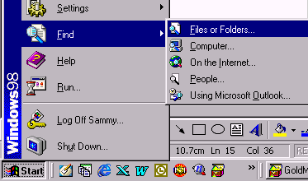
1 ) Press [Start] button and “Find >> Files or Folders”.
On windows 2000 this is “Search >> For Files and Folders”
2 ) Search C (or Enterprise directory on server) drive for “PostTran” files:
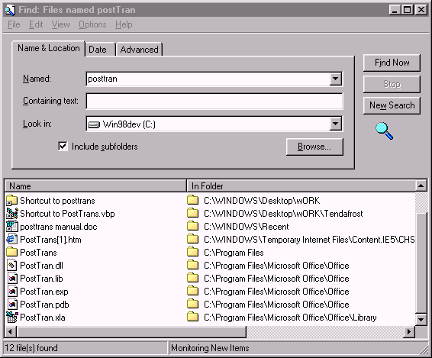

3 ) Then delete PostTran.xla and PostTran.dll on the C drive. If you cannot see the PostTrans.dll you need to turn on “Show hidden files and folders” in windows explorer.

4 ) Now Open Excel
5 ) You should get the following error:

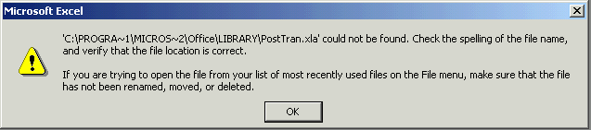

6) Press [OK]

7) Go to the “Tools >> Add-ins” menu in Excel:

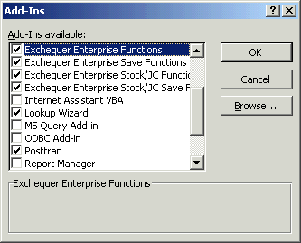
8) Untick the PostTrans option

This will result in Question:

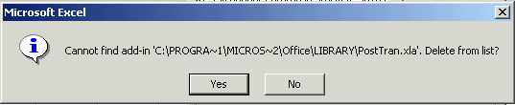

8 ) Press [yes] button

9 ) Press [Ok] button on “Add-ins” window

10 ) Now delete the “PostTrans” Toolbar, by right clicking on the grey region adjacent to the toolbars, in Excel, and select “customise”:

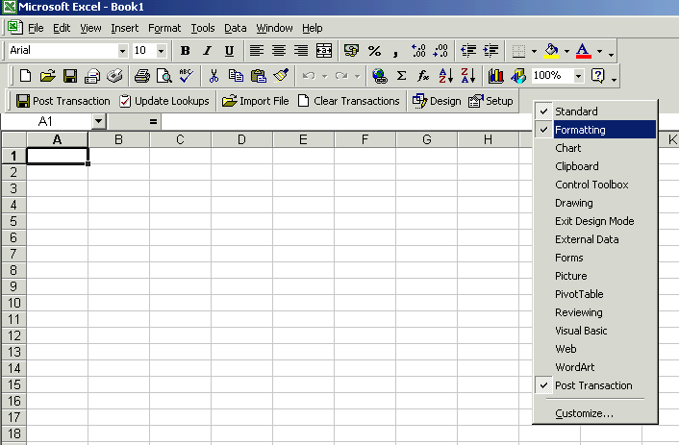
Right click here
Select “Customize”

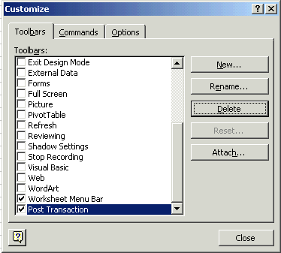
11 ) Select “Post Transction” option
12 ) Press [Delete] button
13 ) Answer [Yes] when asked if you want to delete toolbar

14 ) CLOSE Excel
THIS MUST BE DONE BEFORE PROCEDING

15 ) Follow the instruction for new installation

